🚀 e-YRC 2026–27 Stage 1: Team 4270 Progress Report
Current Status: 100% Pass Rate across BOTH selected themes. All immediate deadlines met.

1. Theme A: Khoj-o-Drone (KD)
- Task 0 (System Setup): [Score: 100/100]
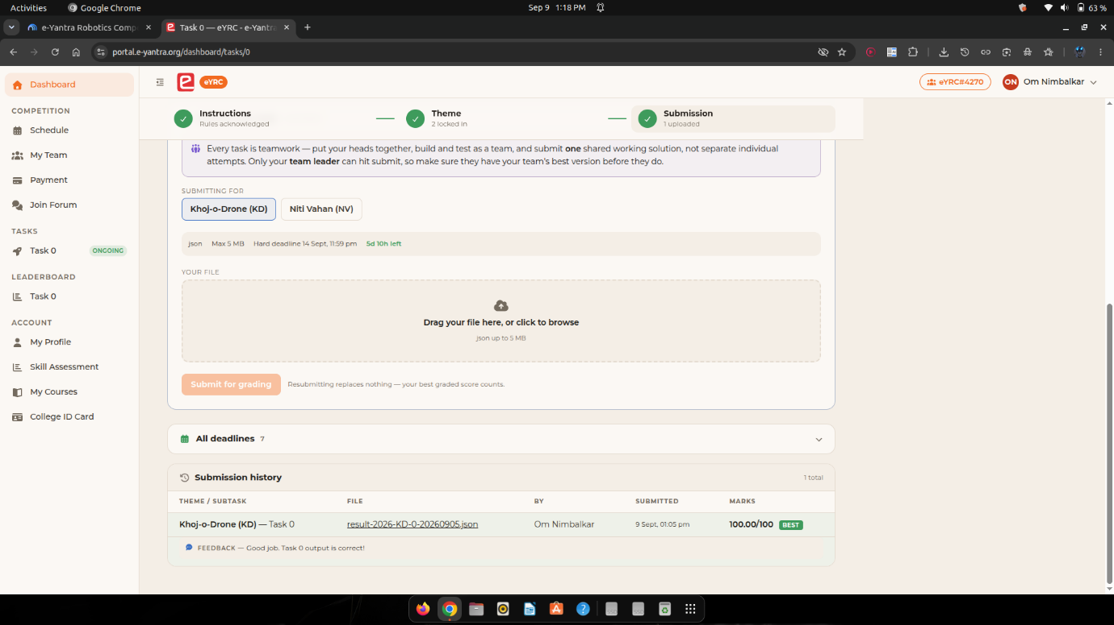
  - Successfully installed the heavy robotics software stack natively on Ubuntu (ROS 2 Humble, OpenCV 5.0, Gazebo).

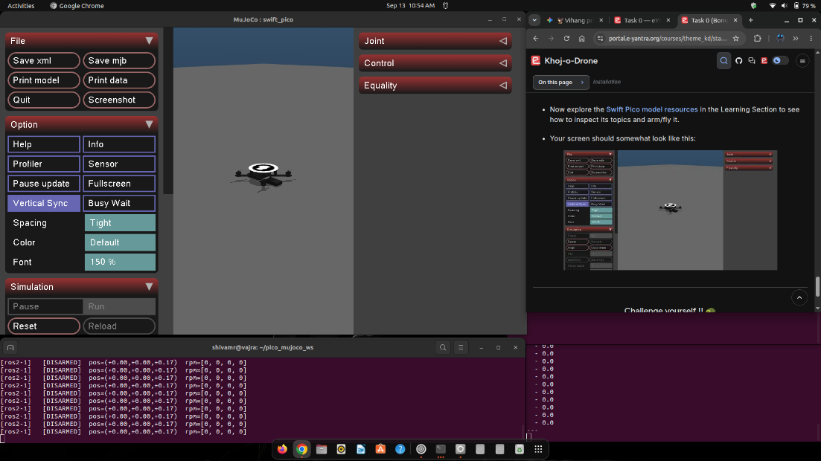
- Task 0 Bonus: [Completed by Shivam]
  - Successfully wrote ROS 2 scripts to make a virtual turtle move in a perfect circle and spawned a 3D quadcopter into the Gazebo physics simulator.

- Task 1A (Vision Pipeline): [Score: 20/20] [Completed by Shivam; Uploaded via Captain's account]
  - What was built: An autonomous computer vision script to detect disaster survivors.
  - How it works: It finds 4 corner barcodes (ArUco markers), digitally flattens the camera angle to a perfect top-down 900x900 grid, and uses color filters (HSV masking) to find Red (Critical) and Yellow (Stable) survivors. It then calculates their exact grid coordinates (e.g., C10, B7).
  - Key Victory: Engineered a custom fallback to prevent the strict e-Yantra grading server from crashing due to OpenCV version differences.
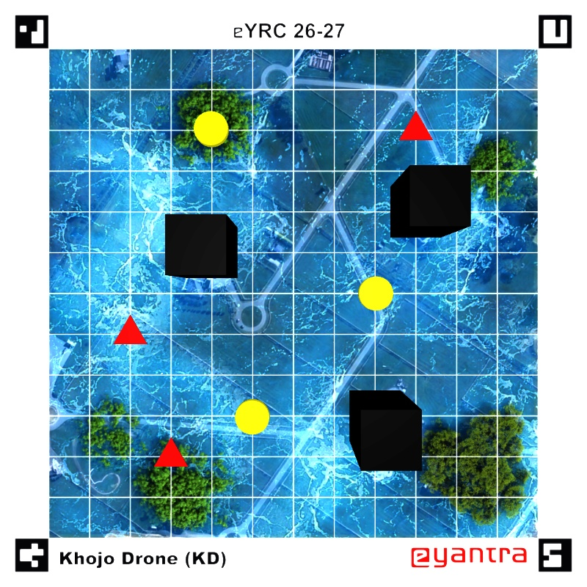

2. Team Dynamics & Next Steps
- Workload Distribution: With the Captain currently unable to contribute due to personal reasons, Shivam has taken the lead on KD development and overarching technical troubleshooting, while Bhumika and Prachi are driving the NV backup theme.
- Upcoming Focus (Task 1B):
  - For KD, we are moving from static images to live drone video feeds and writing a PID controller to make the drone hover stably in the 3D simulator.

3. Theme B: Niti Vahan (NV) - Autonomous Car [Backup Strategy]
- Strategy Note: We successfully maintained this second theme as a safety net per e-Yantra rules, in case drone flight dynamics become too difficult later.
- Task 0 (System Setup): [Completed by Bhumika & Prachi]
  - Successfully set up the Python/Conda environments required for the autonomous car simulation.
- Task 1A (Ackermann Steering): [Completed by Bhumika & Prachi]
  - What was built: A geometry algorithm that calculates the exact angles the front left and right wheels need to turn so the car doesn't skid through corners (Ackermann steering).
  - Key Victory: we done team work and fix a critical math bug (ZeroDivisionError) that was crashing the code when the car tried to drive perfectly straight. It was successfully submitted yesterday to beat the deadline.
